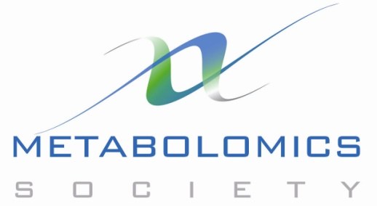

**Metabolomics Society News – October 2013**

We need some “re-launch” text – see draft press release; could steal some text from there.

**Announcement: three new Directors elected onto the Metabolomics Society’s Board**

We’re pleased to announce the results of the 2013 elections for the Board of Directors: the membership of the Society has voted to elect Dr Darren Creek (University of Melbourne, Australia), Professor Oliver Fiehn (UC Davis, US) and Professor Gary Siuzdak (Scripps Research Institute, US). These highly recognised scientists will bring a wealth of experience to the Board and consequently we look forward to developing new and exciting initiatives and benefits for the Society membership. In addition the Board would like to thank the contributions of the departing Directors, Marta Cascante, Matej Orešič and Joshua Rabinowitz.

**Metabolomics Society Annual International Conference Series**

The Board of Directors is very excited to announce the location of its **11th Annual International Conference,** which is to be held in **San Francisco, USA, June 28 to July 2nd 2015**. The conference planning will be led by Professor Oliver Fiehn and the local organising committee, with support from a prestigious international advisory group. Meanwhile, planning for our **10th Annual International Conference,** from **June 23rd to 26th 2014 in Tsuruoka, Japan,** is well underway. Details will be posted at <http://metabolomics2014.org/>

**Announcement: Metabolomics Society’s Early-career Members Network has been initiated**

Following our recent call for early-career scientists to become more actively involved in the Society, we are pleased to announce that the following three young scientists will be joining our **Strategy Task Group** for one-year rotations:

* Mr David Liesenfeld, German Cancer Research Centre, Germany
* Mr Thomas Payne, Imperial College London, UK
* Dr Sastia Putri, Osaka University, Japan

In addition to their role to help shape the future growth of the Society, particularly to develop benefits for early-career researchers, they will also join the following scientists who have collectively formed the first committee of the new **Early-career Members Network**.

* Dr Vincent Asiago, DuPont Pioneer
* Ms Evangelia Daskalaki, University of Strathclyde
* Dr Lindsay Edwards, King’s College London
* Dr Nicholas Rattray, University of Manchester
* Ms Gabriel Valbuena, Imperial College London
* Dr Ralf Weber, University of Birmingham

Congratulations to all of these individuals for being selected for these important roles. More about the new **Early-career Members Network** to follow soon.

***Metabolomics* journal, Vol. 9, Issue 5, October 2013**

See the latest issue of our journal at: <http://link.springer.com/journal/11306/9/5/page/1>

In addition to the many excellent research papers, each issue contains a section of typically four pages that is contributed by the Society. For the October 2013 issue there are three short pieces:

* *News*: [2013 Honorary Fellows of the Metabolomics Society](http://link.springer.com/article/10.1007/s11306-013-0578-x)
* *News*: [Metabolomics Society’s annual *Metabolomics* publication awards](http://link.springer.com/article/10.1007/s11306-013-0577-y)
* *Report*: [Report on the 9th Annual International Conference of the Metabolomics Society](http://link.springer.com/article/10.1007/s11306-013-0579-9)

Stay abreast of the latest metabolomics news via the Twitter feed on the front page of the website. Also you can follow us on **Twitter:** Metabolomics Society [@MetabolomicsSoc](https://twitter.com/MetabolomicsSoc) and *Metabolomics* journal [@Metabolomics](https://twitter.com/metabolomics). And you can [visit us](http://www.facebook.com/pages/Metabolomics-Society/356630484432997) on **Facebook.**

Mark Viant, President

[President@MetabolomicsSociety.org](mailto:President@MetabolomicsSociety.org)